**Structured Query Language**

Name: Kennedy Kabaso.

Strayer University.

Week 7 Lab 4

CIS 111

Intro To Relat Dbase Mgt Syst

Professor: Besharatian Hossein.

November 20, 2017

**Table of Content.**

**Cover Page -------------------------------------------------------------------------------------- Page 1**

**Screen shots ------------------------------------------------------------------------------------- Page 3**

**Screen shots-------------------------------------------------------------------------------------- Page 4**

**Screen shots-------------------------------------------------------------------------------------- Page 5**

**Screen shots-------------------------------------------------------------------------------------- Page 6**

**Screen shots-------------------------------------------------------------------------------------- Page 7**

**Screen shots-------------------------------------------------------------------------------------- Page 8**

**Relationships diagram---------------------------------------------------------------------- Page 10**

**Structured Query Language**

1. Create the tables and relationships from the database design discussed in Lab 2.

Screen shot depicting the tables created within MySQL

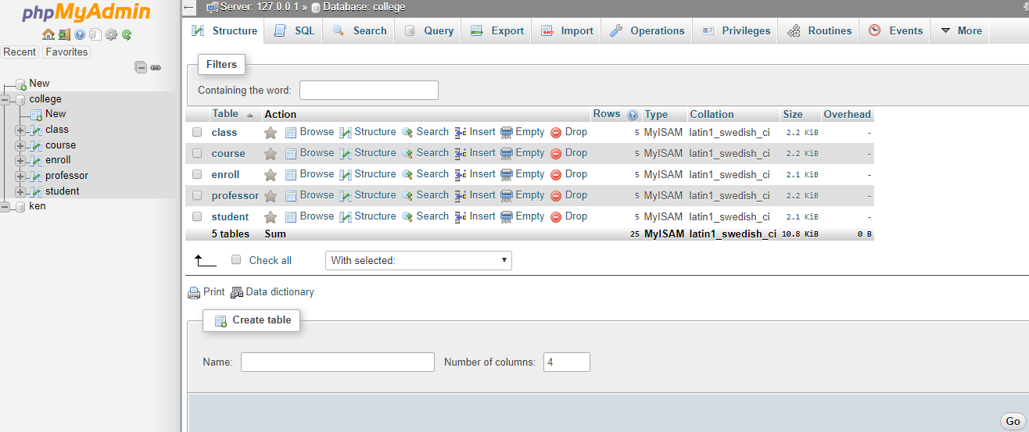

1. Add at least five (5) records into each table (Note: You must determine the field values).

* Screen shots depicting the records added into each table

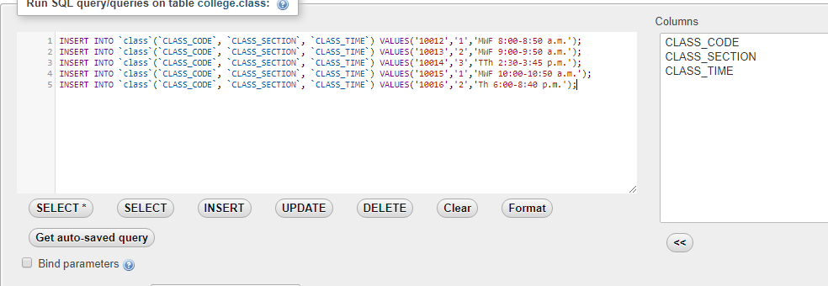

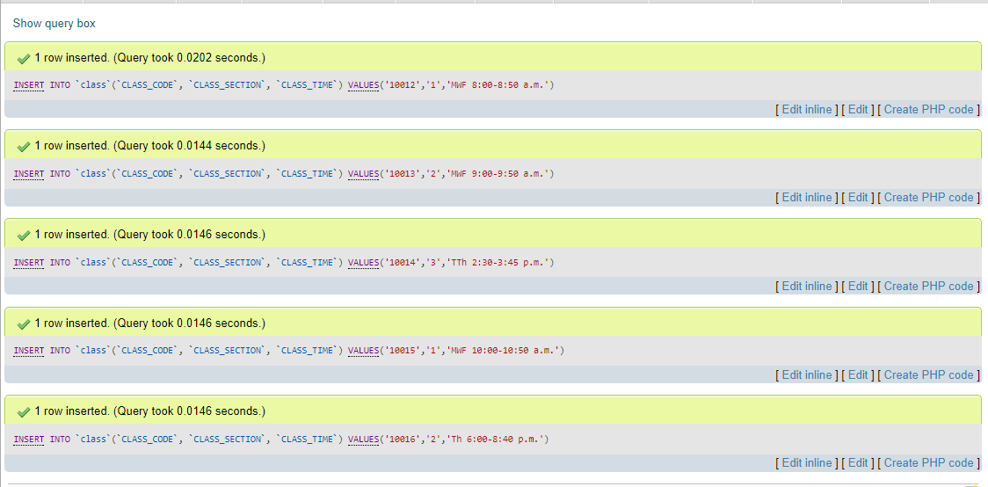

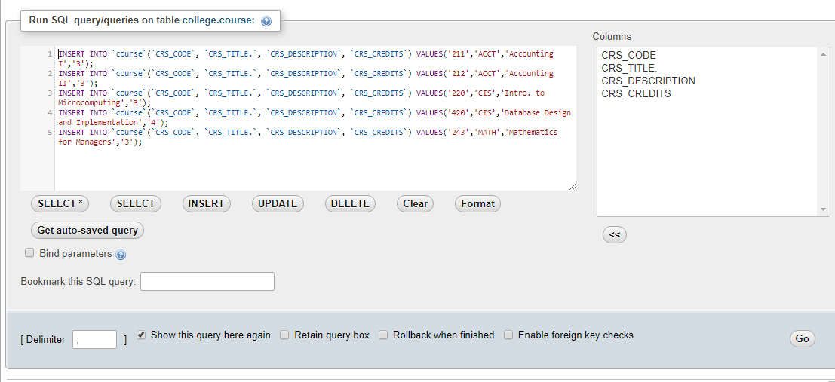

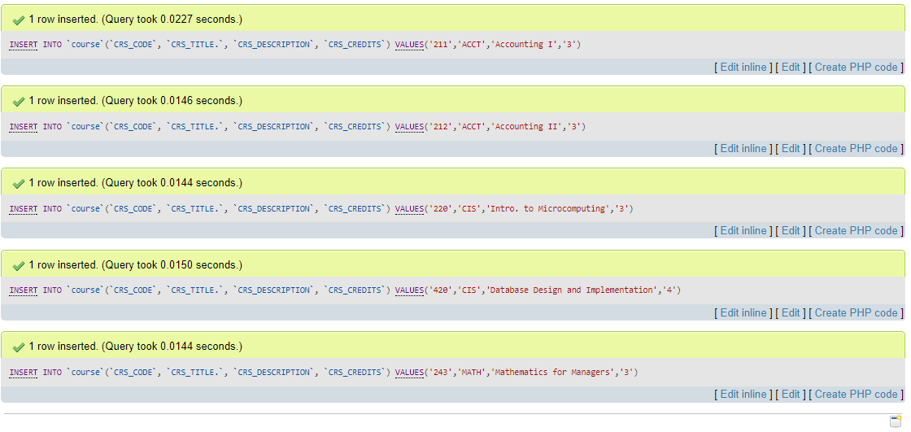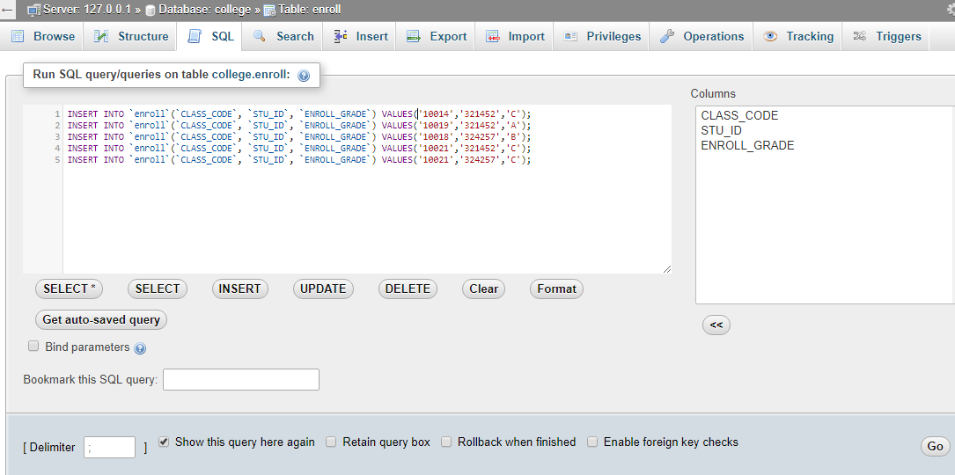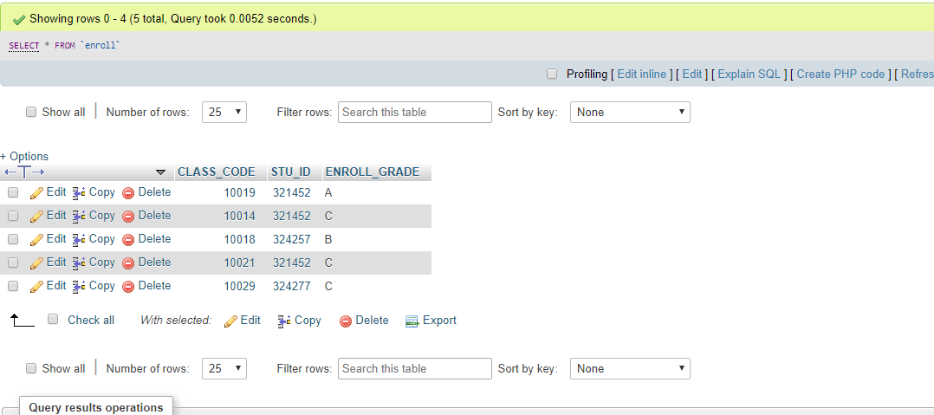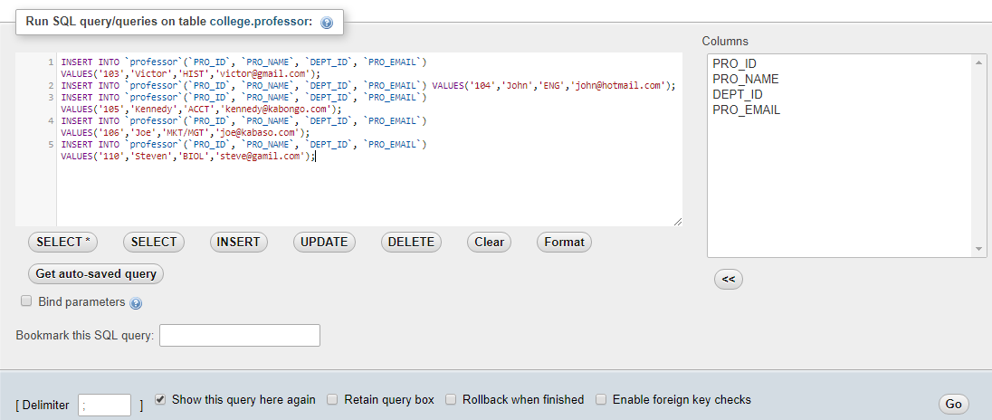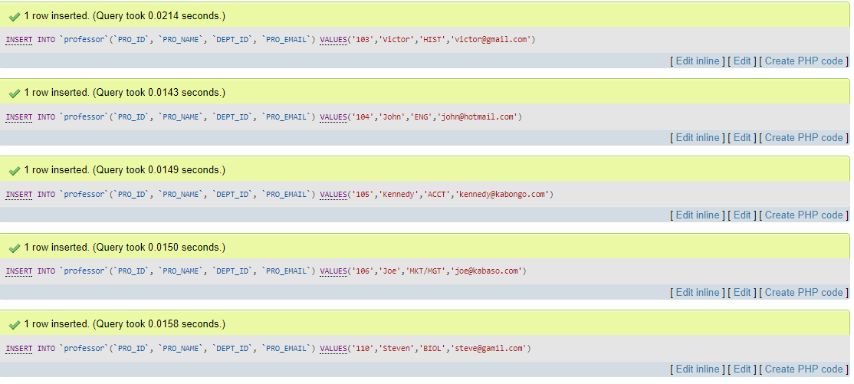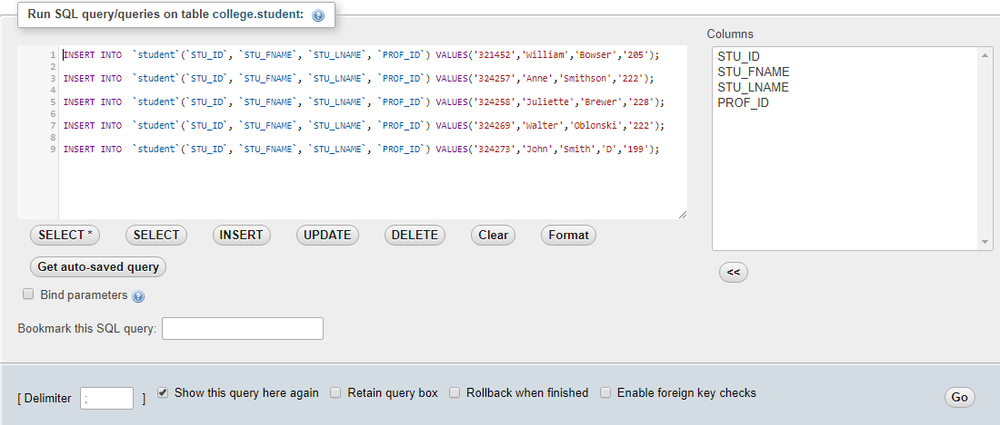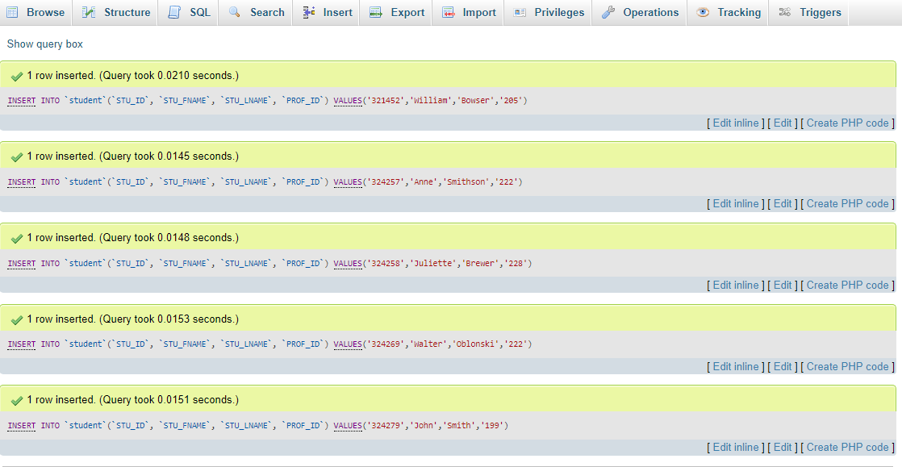

1. Create a query with all fields from the student table, where the student's last name is "Smith".

* Screen shots depicting the SQL code and the query results from each of the queries created.

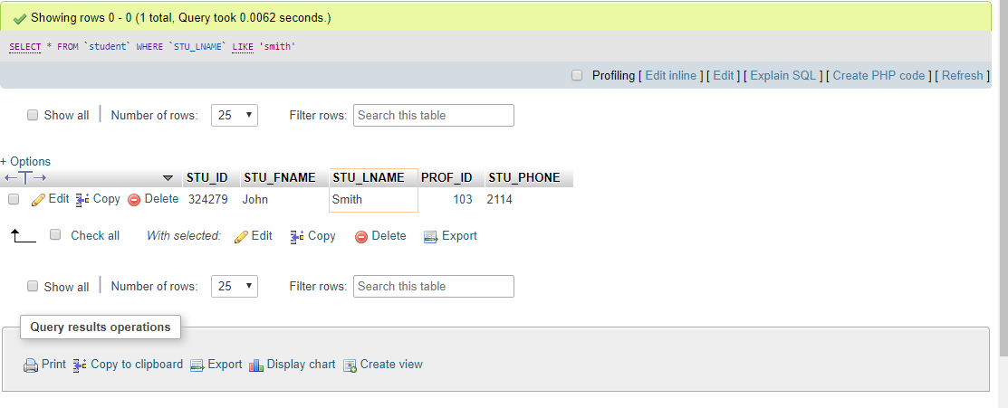

1. Create a query that includes students’ first names, last names, and phone numbers.

* Screen shots depicting the SQL code and the query results from each of the queries created.

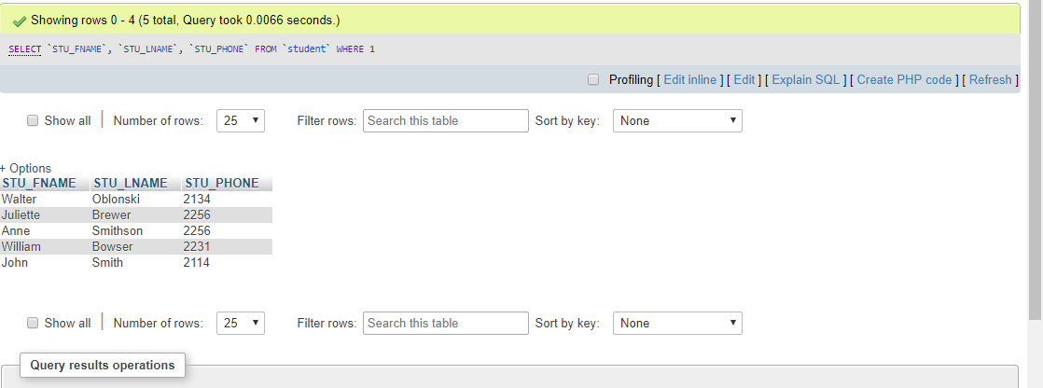

1. Create a query that includes instructors' first names, last names, and courses they teach.

* Updated Professor table

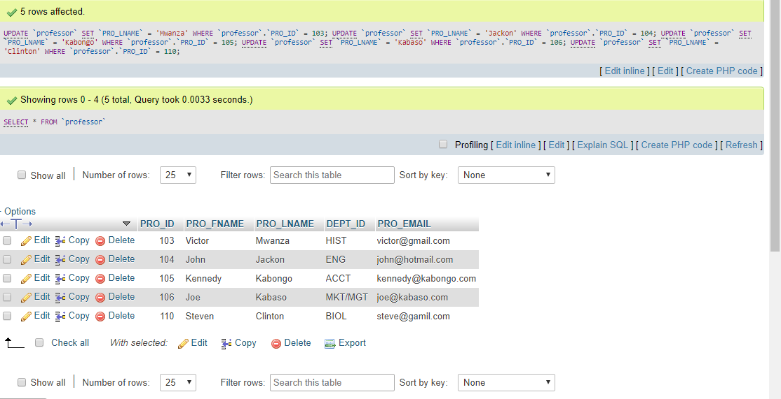

Screen shots depicting the SQL code and the query results from each of the queries

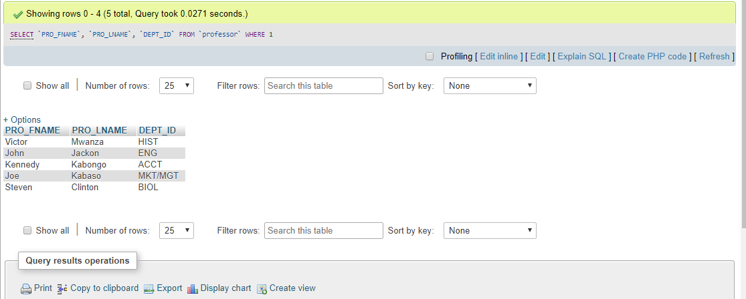

1. Relationships diagram

* Screen shots depicting the SQL code and the query results from each of the queries created.

